**IQmol Lab 1: Basic Building**

*We will build ethane and determine the energy difference between staggered and eclipsed ethane at the B3LYP/6-31G level of theory. (~10 minutes)*

* Build a staggered ethane molecule (from Add Fragment > Molecules > Ethane).
* Submit to the IQmol server using the Calculation > Q-Chem Setup menu. Be sure to select “B3LYP” as the method and “6-31G” as the basis set.
* Once the calculation is done, a dialogue box will pop up. Copy the results from the server back to a directory on your local machine.
* Build an eclipsed ethane molecule:
  + Create a new molecule (via New Molecule button or File > New Molecule) and build another ethane molecule.
  + In Select Mode (via Select Mode button), select the dihedral between a C1 hydrogen, C1, C2, and a C2 hydrogen.
  + Under Build > Set Geometric Constraint, set the torsion angle to 0.0°.
* Submit the eclipsed ethane job and copy the results back. (Don’t forget to hit the “Reset” button to clear information from previous jobs, and then reselect the appropriate method and basis set before submitting.)
* Determine the energy difference between the two conformers:
  + Obtain the energies of the staggered and eclipsed ethanes. There are two possible ways to do this:
    - Look at the number printed in “Geometries”, or
    - Open the raw output file (see the “Files” tab under the calculation in the Model View window) and find the last line labeled “Total energy in the final basis set”.
  + What is the energy difference?

| *Ethane (Staggered)* | *Ethane (Eclipsed)* |
| --- | --- |

**IQmol Lab 2: Basic Visualization**

*Build a benzene molecule, run a B3LYP/6-31G single point energy calculation on it, and analyze the resulting output file using IQmol. (~10 minutes)*

* Build a benzene molecule (from Add Fragment > Molecules > Benzene).
* Set up a B3LYP/6-31G single-point energy calculation, and submit to the IQmol server using the Calculation > Q-Chem Setup menu.
* Once the calculation is done, copy the results back to your local machine.
* Analyze the results:
  + What is the dipole of this molecule? Is there one?
  + Visualize the following (Surfaces > Canonical Orbitals, under Model View):
    - HOMO and LUMO (What is the HOMO/LUMO energy gap?)
    - Total electron density for the molecule
    - Mulliken charges or ESP

*Now, investigate the effects of adding groups onto the benzene ring.*

* Do a B3LYP/6-31G calculation on aniline (benzene with an NH2 group).
* Create a new molecule (using a benzene molecule as the base, adding an amine group from the Add Fragment > Functional Group menu, and then minimizing using the Minimize Energy button) and submit the calculation.
* Submit the calculation and copy back the results.
* Visualize:
  + The total electron density
  + The Mulliken charges or ESP
* Now, do the same process for nitrobenzene (benzene with an NO2 group).
* Analyze the results:
  + How does the dipole change when NH2 is added? What about NO2?
  + How does the electrostatic potential change?

| *Benzene* | *Aniline* | *Nitrobenzene* |
| --- | --- | --- |

**IQmol Lab 3: Optimization & Frequency Visualization**

*Run a two-part job (HF/6-31G optimization, followed by a frequency calculation) on acetic acid and analyze the results. (~10 minutes)*

* Build acetic acid (available under Add Fragment > Molecules > Acetic Acid).
* Create a two-part HF/6-31G optimization and frequency job:
  + Set up the HF/6-31G optimization part, as usual.
  + Click the “+” button. This should create a new job section in the input file.
  + Make the second job a HF/6-31G frequency job.
  + Submit the calculation as usual.
* Copy results back to your local machine.
* Visualize the geometry optimization:
  + Click on individual energies under “Geometries” in Model View to see the geometries at each optimization step.
  + Double-click on “Geometries” to see a graph of the geometry optimization steps. You can click on individual points on the graph to visualize the geometry at each step.
* Visualize the resulting spectrum:
  + Under Model View, visualize the frequency.
  + Click on a specific frequency to visualize the arrows.
  + Double click on a specific frequency to trigger animation.
  + Double click on the Frequencies menu item to pull up the whole spectrum.
* Which frequency has the largest amplitude? What is the character of the associated vibration (i.e. is it twisting, stretching, rocking)?

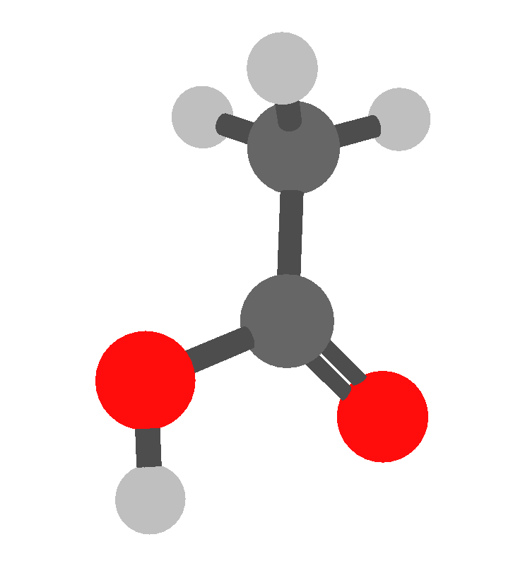

*Acetic Acid*

**Answer Key**

**IQmol Lab 1: Basic Building**

| Ethane (Staggered) | -79.8122487568 |
| --- | --- |
| Ethane (Eclipsed) | -79.8073923437 |
| Difference | 0.0048564131 |

**IQmol Lab 2: Basic Visualization**

*Part 1*

HOMO-LUMO Gap: 0.245 Eh

| HOMO (a21): | LUMO (a22): |
| --- | --- |
| Total Density: | Mulliken: |

*Part 2*

*Aminobenzene*

| Total Density: | Mulliken: |
| --- | --- |

*Nitrobenzene*

| Total Density: | Mulliken: |
| --- | --- |

**IQmol Lab 3: Optimization & Frequency Visualization**

*Optimization Results*

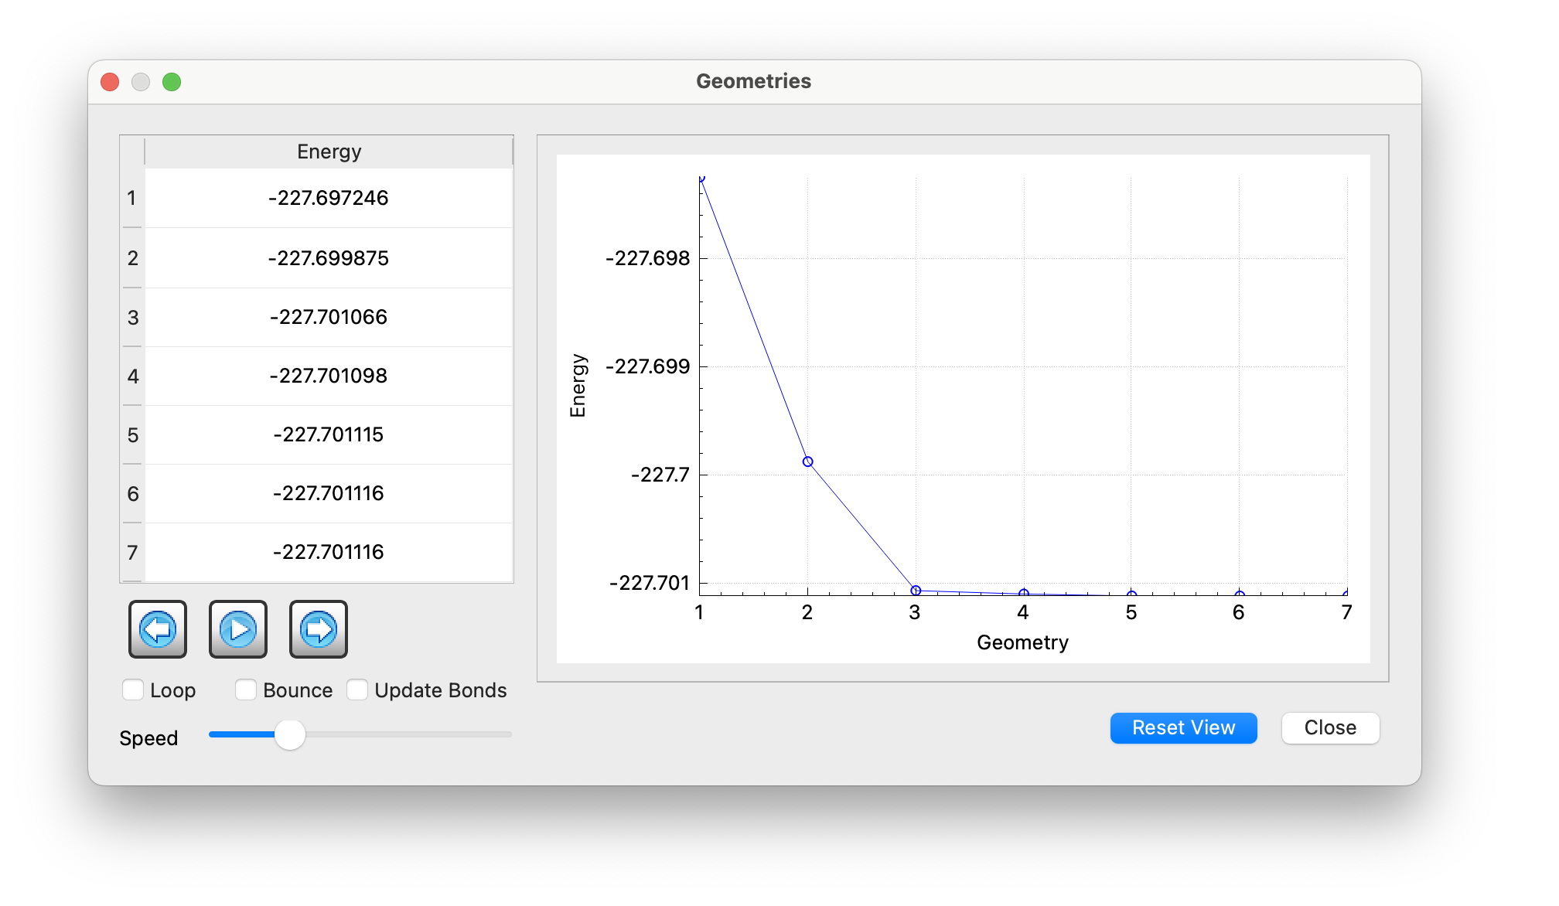

*IR Spectrum Results*

Highest-Magnitude Frequency: 1925 cm-1

|  |  |
| --- | --- |